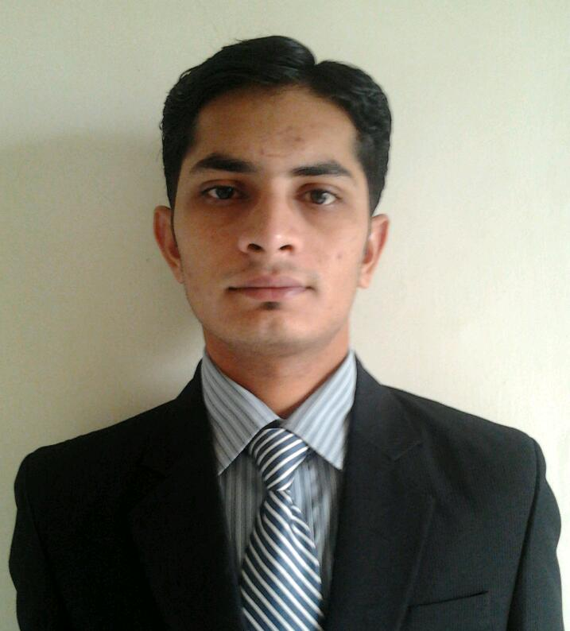
NAME:- GHANSHYAM MORASIYA
ADDRESS:- “Shreeji Krupa”, Narayanpaara-2,
Ratanpar, Surendranagar-363020
Gujarat, India.
Co. detail :- +91 82689 48068
E-mail:- morasiya.shyam@gmail.com

CAREER OBJECTIVE:_______________________________________________

To be a part of a progressive Organization where my skills and knowledge can be utilize towards the advancement of the Organization and also my growth.

WORK EXPERIENCE:________________________________________________

Name of the organization : WIN-MEDICARE PVT LTD.
Position Held : Professional Sales Representative
Duration : Nov 2007 to August 2008 (10 Months)
Job Profile : To visit Doctors & Chemists.
And avail company products.
EDUCATIONAL QUALIFICATIONS:___________________________________
Professional:

DEGREE | YEAR OF PASSING | INSTITUTE/UNIVERSITY | PERCENTAGE
MBA | Currently  Pursuing | Indian Institute of Planning and Management,  Gulbarga University. | 58.40 %

Academic:

DEGREE | YEAR OF PASSING | INSTITUTE/UNIVERSITY | PERCENTAGE
GRADUATION  (B.Sc.) | April 2010 | M.P.Shah Science College,  Saurashtra university. | 58%
HSC | March 2005 | D.N.T. High school,  Gujarat Board. | 40%
SSC | March 2003 | R.A. Patel High School,  Gujarat Board. | 63%

PROJECTS HANDLED:_______________________________________________

Desk Projects:

Project Title | Project Objective
1)Product launch  Tea Cubes-Dubi Dubi | To launch a non-existing product in the market.  i.e. Tea Cubes-mixture of sugar, tea & milk dry powder, flavours & preservative.
2)Leadership project | Skills of a Personality-Ronald Reagon(40th U.S. president) i.e. Leadership, Motivation, Humour
3)Movie Presentation (Invictus) | Leadership, Motivation, Moral support, Inspiration, Team building, Decision making & Performance.

HOBBIES AND INTEREST : ______________________________
- Social networking
- Travelling
- Music

PERSONAL DETAILS :_______________________________________________

Date of Birth | 6 sept 1987 | Nationality | Indian
Gender | Male | Marital Status | Single
Father’s Name | Mr. Himmatlal Morasiya | Languages Known | Gujarati

I hereby declare that all the information provided by me in this application is factual and
correct to the best of my knowledge and belief.

-------------------
GHANSHYAM MORASIYA

